**Experiment-16**

Change Hardware compatibility of a VM (Either by clone/create new one) which is already created and configured.

**Implementation:**

**Step-1:**

First install VMware workstation in your pc/laptop. Then open already created any VM.

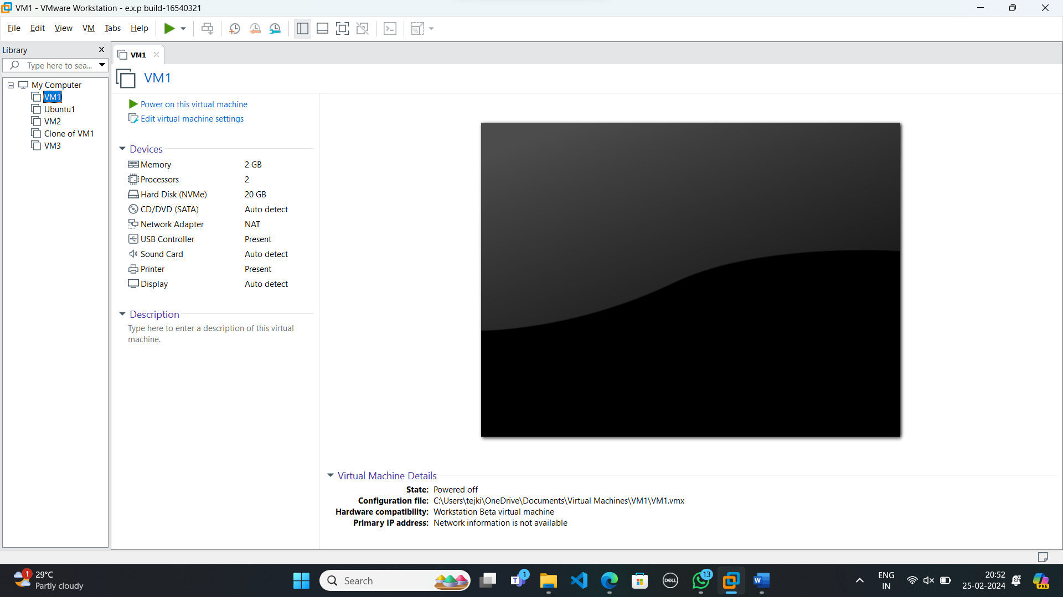

**Step-2:**

Right click the vm and Goto Settings.

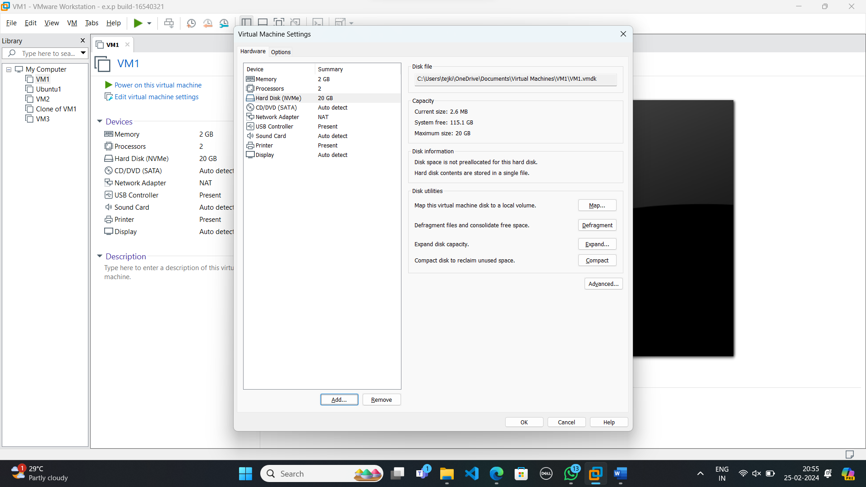

**Step-3:**

Select Add then Hardware option, select SCSI and click next.

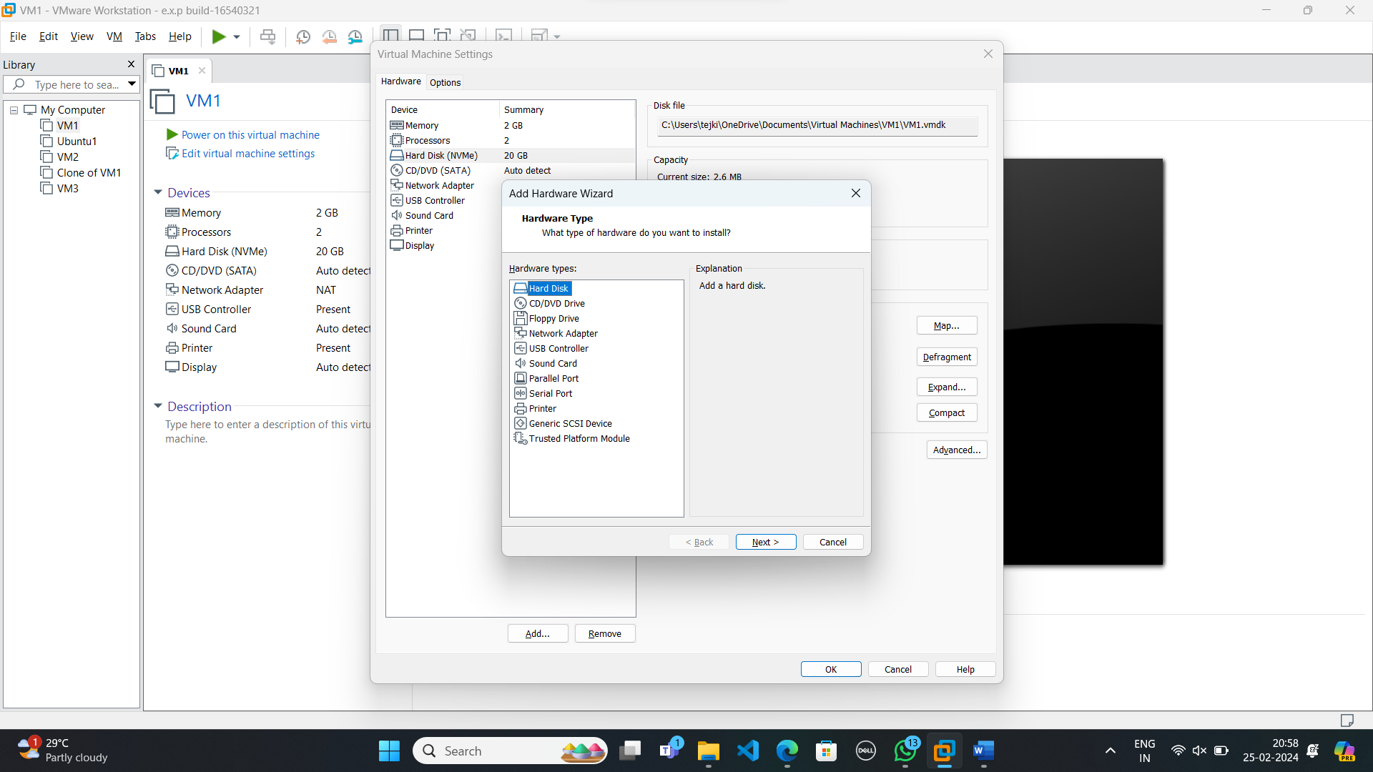

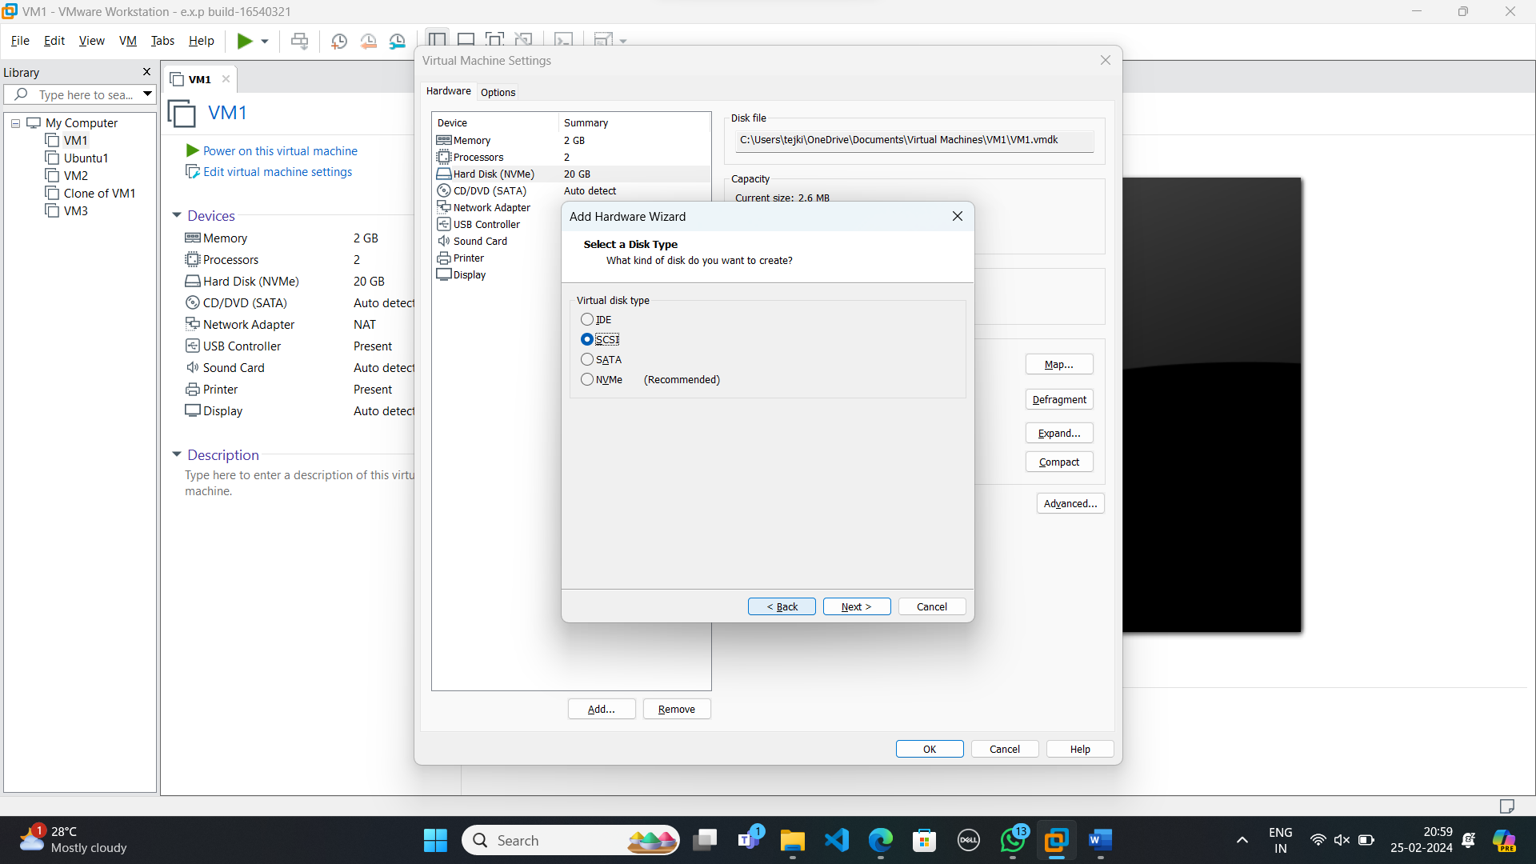

**Step-4:**

Select Create a new virtual disk.

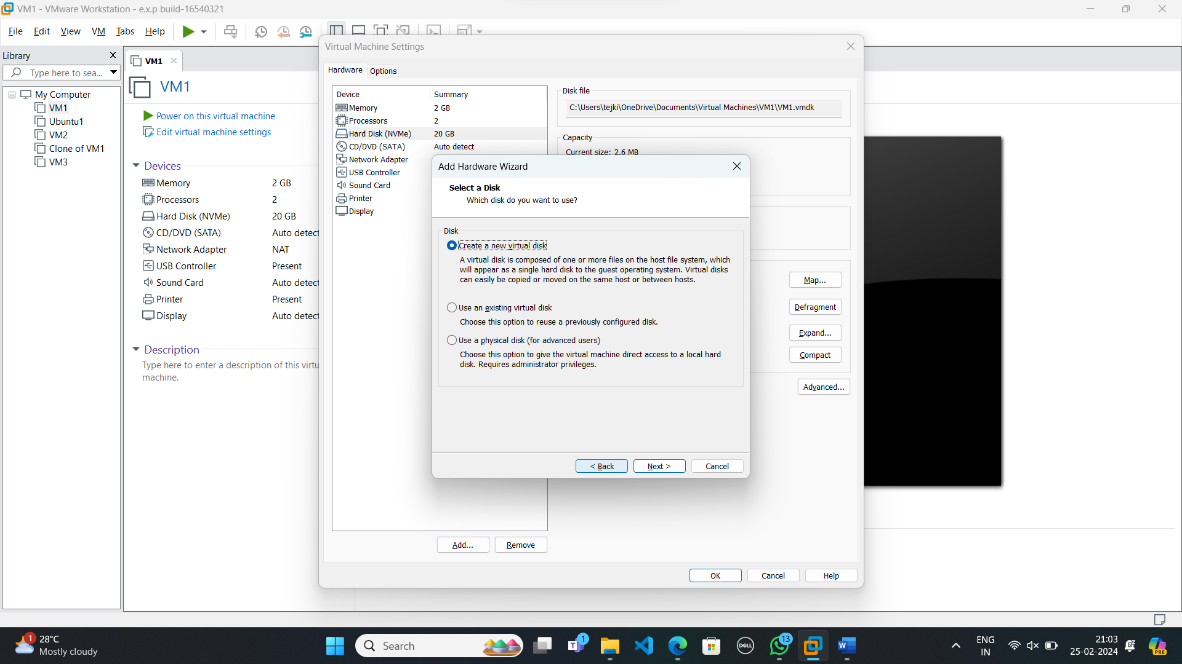

**Step-5:**

Select Disk size as 20.0 and select store virtual disk into single file.

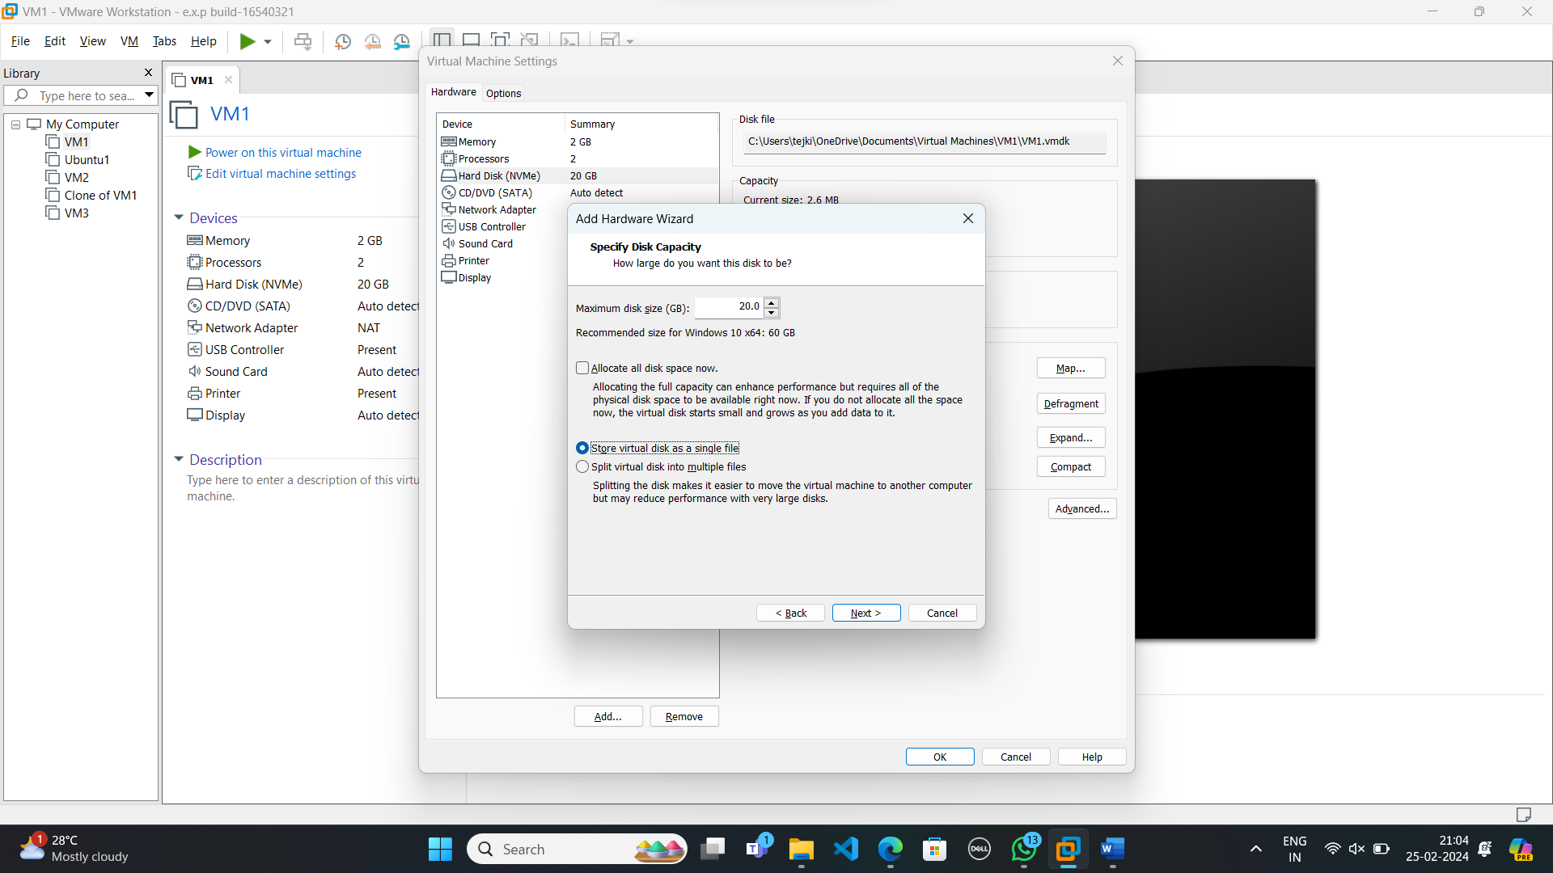

**Step-6:**

Give name and then finish.

